Adding alt text to your documents

Image descriptions help students with visual impairments to perceive images. They also make it easier to understand the context in which an image is being used.

Adobe Acrobat DC

Steps
- Download and open the file in Adobe Acrobat DC. If you do not have Adobe Acrobat DC, see instructions for using Microsoft Word.
- Search tools for ‘Set Alternative Text’ (Fig.1)
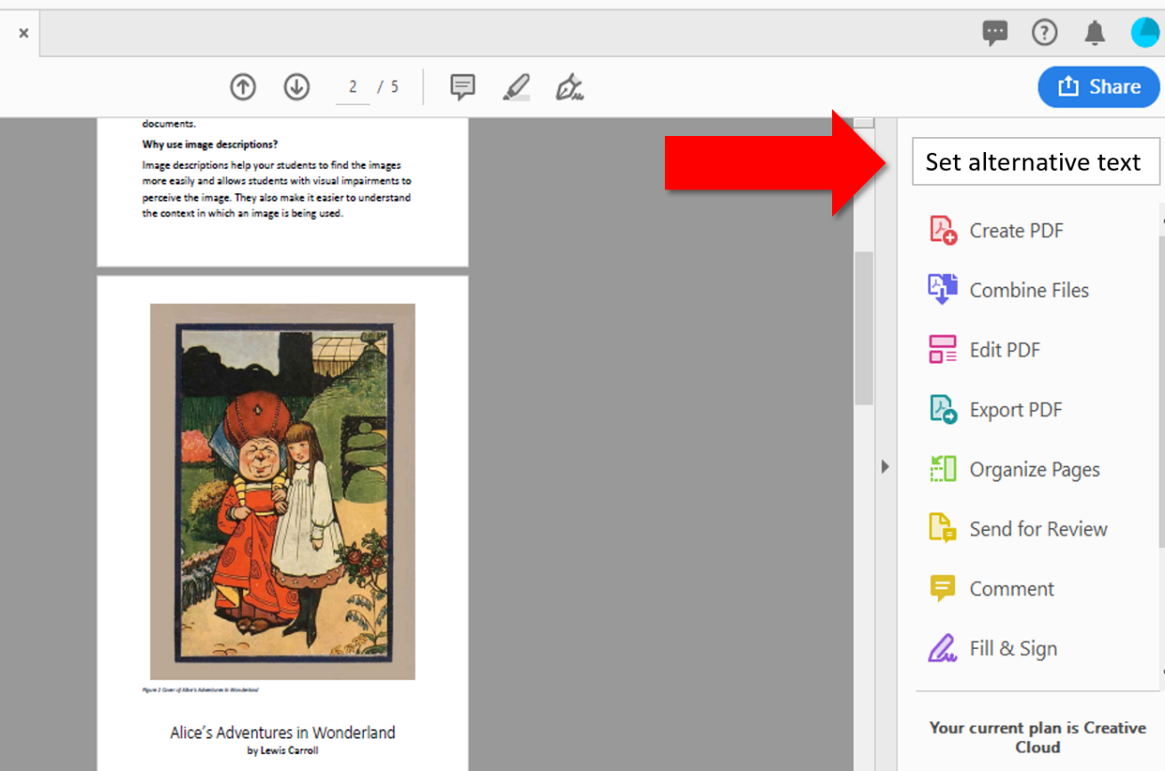
Figure 1 set alternative text
- A window will appear to add text descriptions (Fig.2). Save the document.
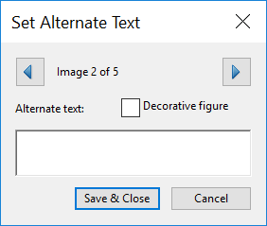
Figure 2 add alt text descriptions

Microsoft Word

Steps
- Open the document in Microsoft Word.
- Right-click an image and select Format picture (Fig.3)
- In the Format Picture panel, click the Layout & Properties tab then open the Alt Text section (Fig.3)
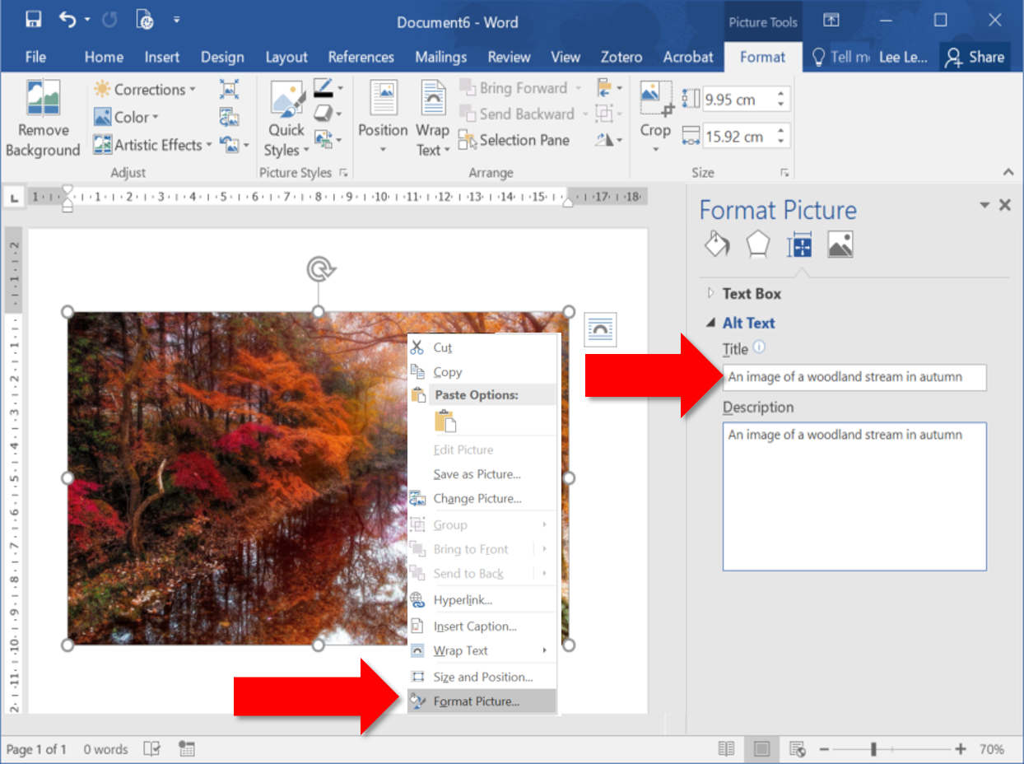
Figure 3 Adding alternative text
- Enter a clear description for the image in the Description box.
- Repeat these steps for all images in the document. Save the document.

Office 365

